**1.Deployment:-** Placing the web application in server is called deployment.

**2.UnDeployment:-** Removing the web application from server is called un deployment.

3**.Deployment Types:-** There are two types of Deployments.

3.1.Cold Deployment:- when server is in stopped mode,if u deploy web application then it is called Cold Deployement.

3.2.Hot Deployment:- When server is in running mode, if u deploy web application then it is called Hot deployemnt.

Ex:- Console deployment and tool based Deployment is Hot Deployment.

**4.We can deploy the java web application in server in 3 modes:**

1. Console Deployment.
2. Hard Deployment.
3. Tool Based Deployment.(Eclipse IDE,Maveen,Grav

**A.Console Deployment:-** we deploy web application as war file using Server console.

**A.1) Deploy Web application Warfile using Tomcat Server:**



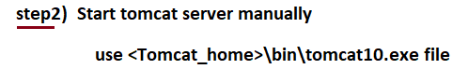

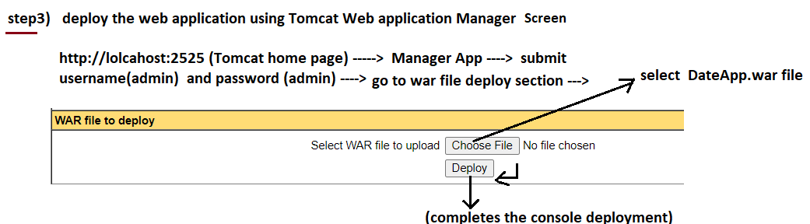

Note:- War file will be extracted by tomcat server.



**A.2) UnDeploy the Web Application using Tomcat Server :**

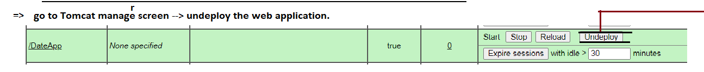

**B.Tool Based Deployment:-**  we use tools(Eclipse IDE,Maveen,..etc) to deploy or undeploy the web application.

**B.1. Deploy and Un Deploy web application using Eclipse IDE:**

